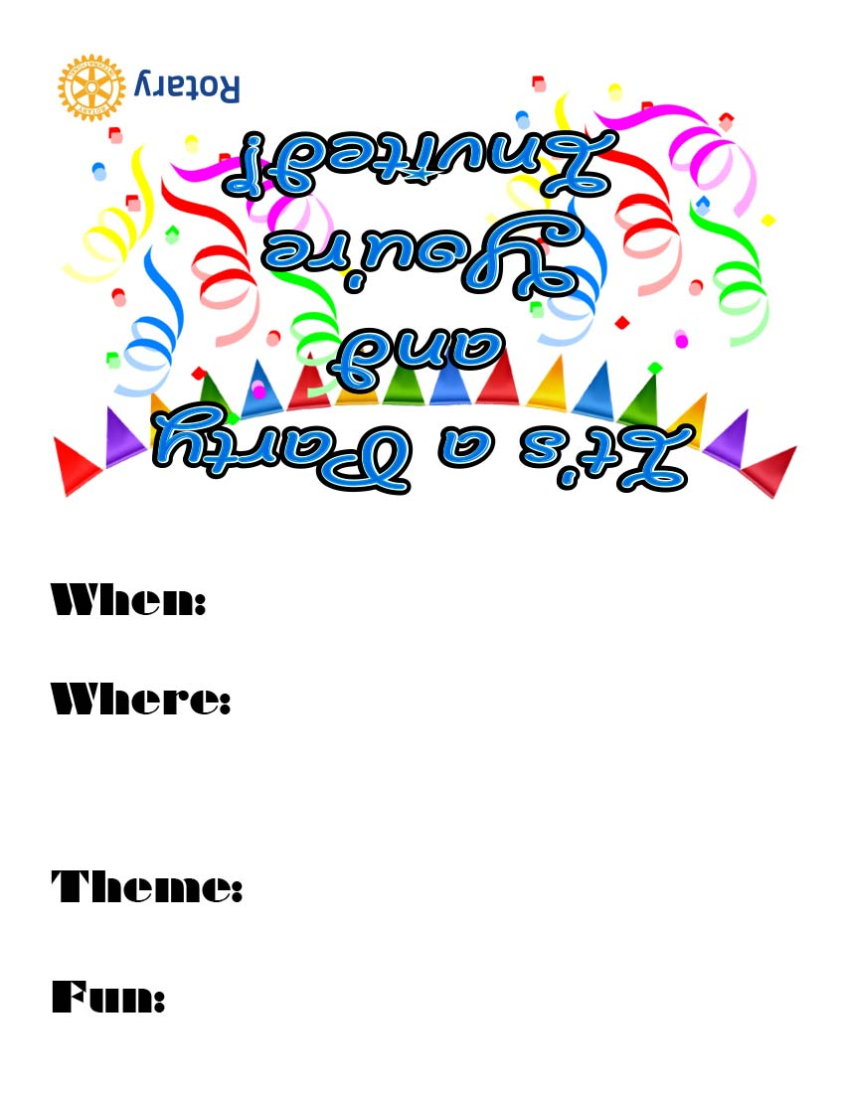

Margarita Mixer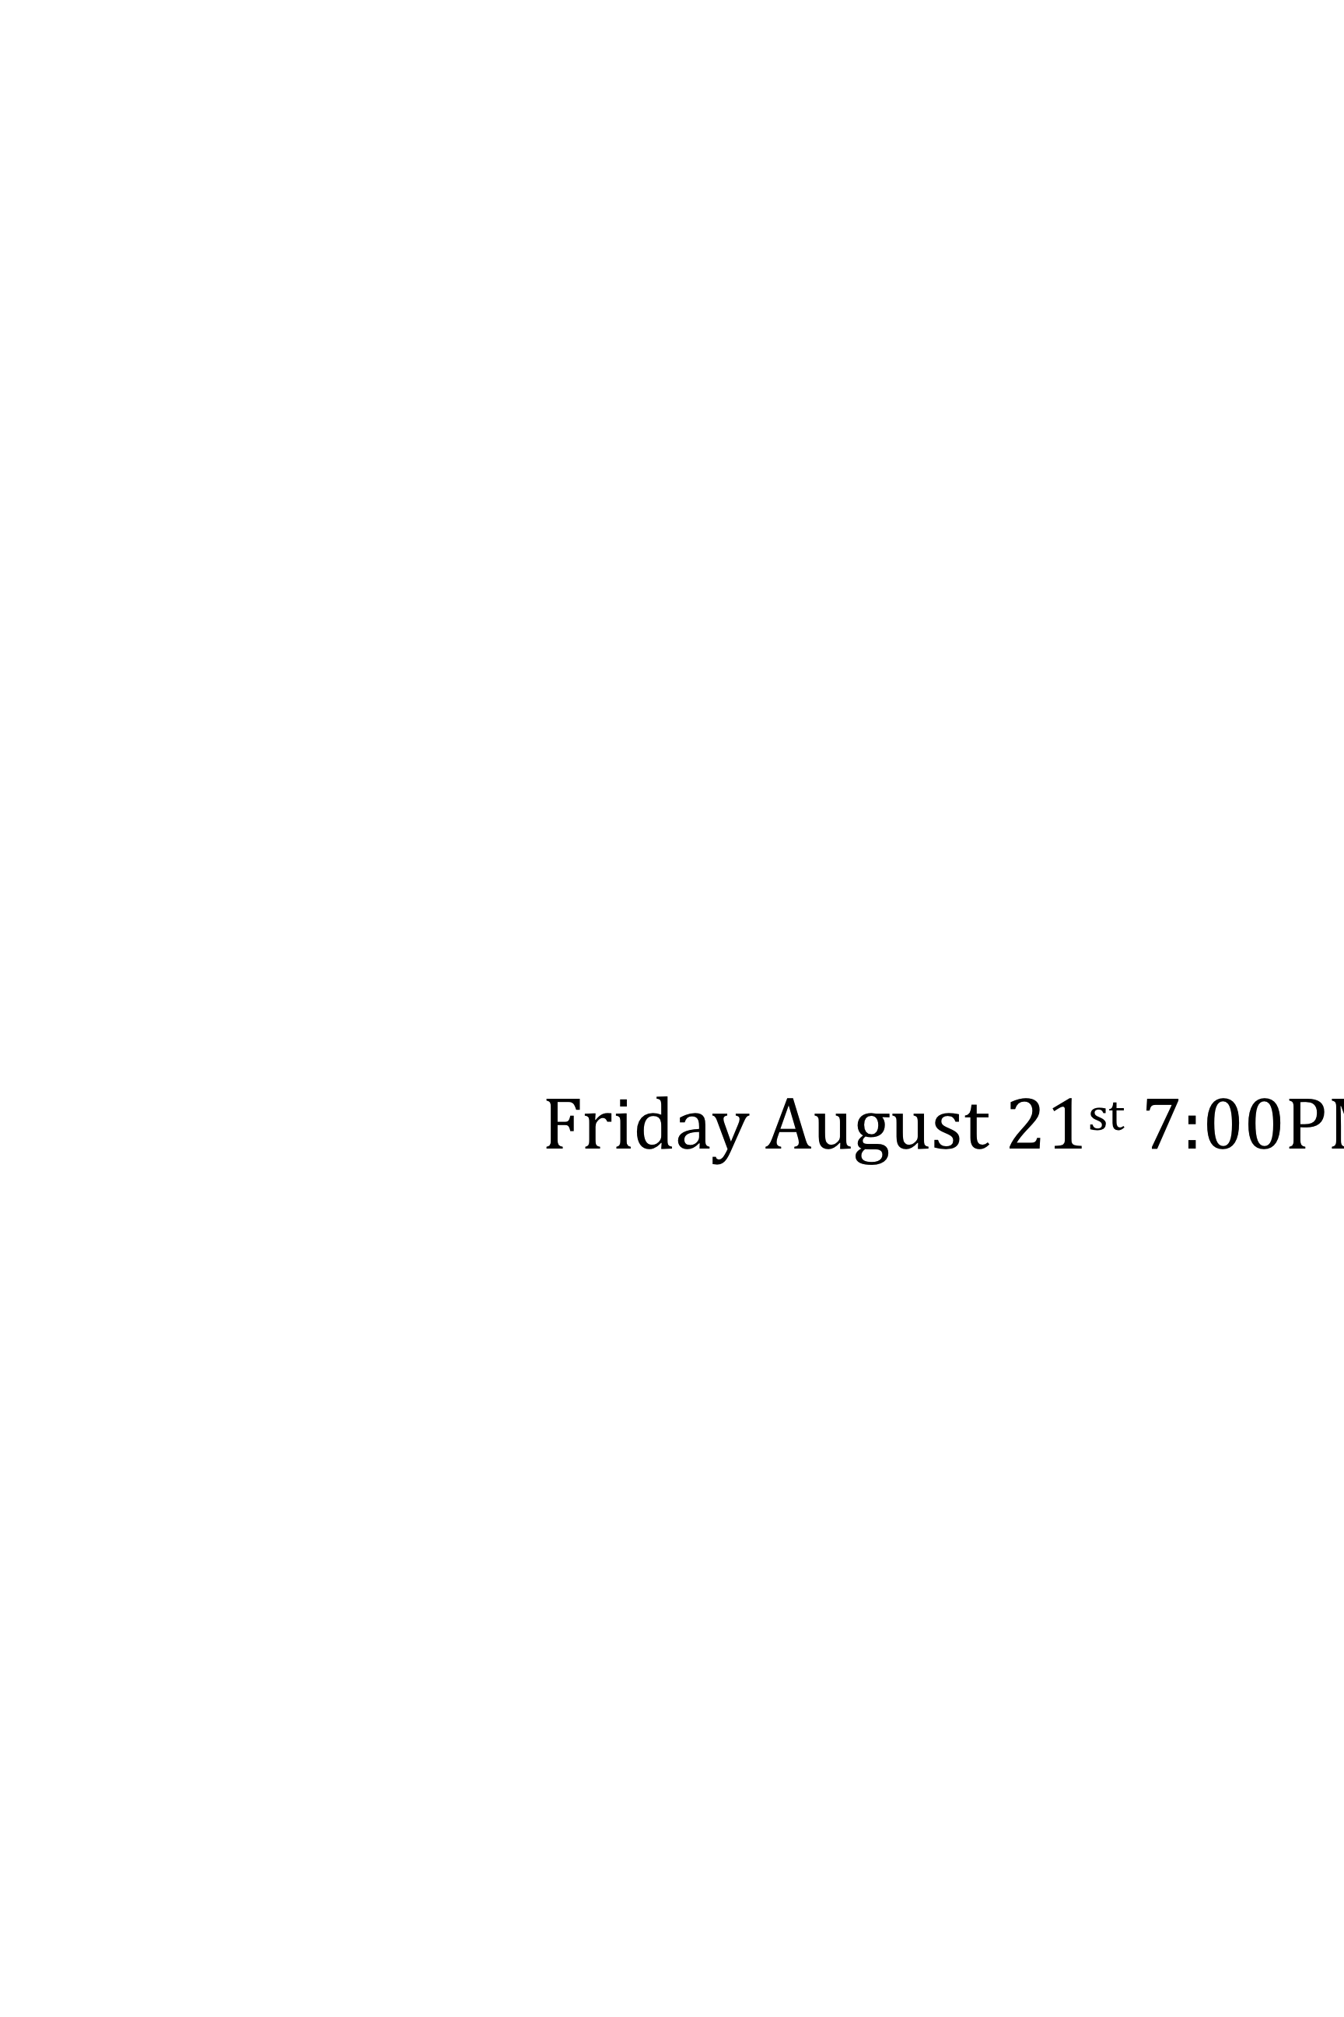

Music Drinks Food

Fellowship

Scott & Debbie Yochum’s House

422 Summit Overlook Dr

Dawsonville, GA 30534

Phone# ???-???-????

Friday August 21st 7:00PM